Project Exercise Schematic

Step 1: Type Eagle in Search bar.

Step 2: Login into Eagle using email [uaeinsautodesk@gmail.com](mailto:uaeinsautodesk@gmail.com) and hit Next.

Step 3: Type in password Password123

Step 4: Create New Project called Exercise. Click File, New, and Project. Name the project Exercise as shown in Figure 1.

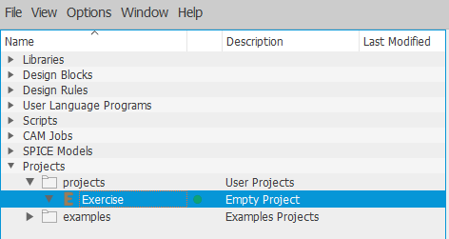

Figure 1: Project Exercise

Step 5: Right click on the project Exercise. Click New, Schematic

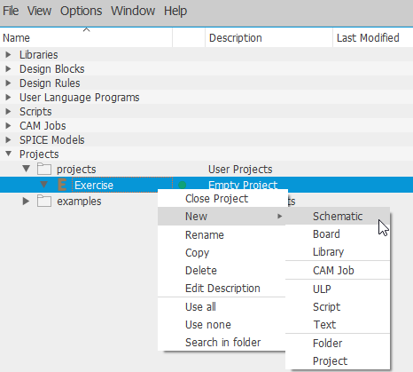

Figure 2: Open New Schematic under Project Exercise

Step 6: New Schematic window should pop up as shown in Figure 3.

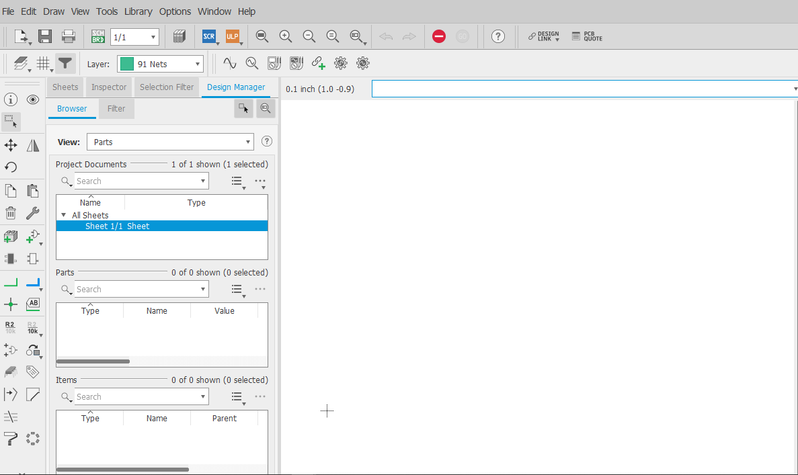Figure 3: New Schematic Window

Step 7: Let’s build the schematic shown in Figure 4.

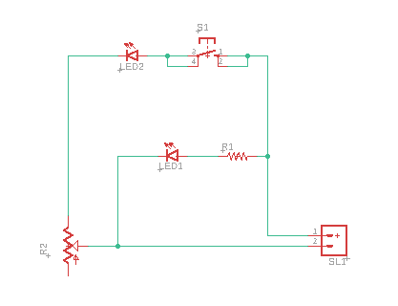

Figure 4: Build This Schematic.

Step 8: Press the Add Part as shown in Figure 5.

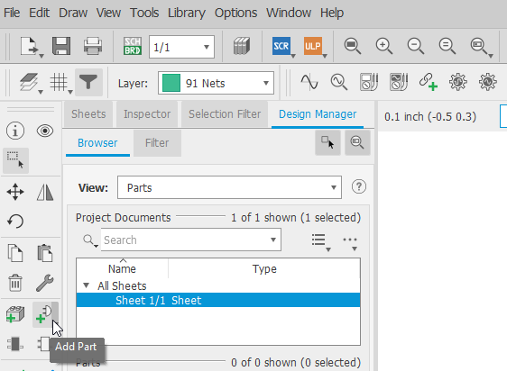

Figure 5: Add Part

Step 9: Add the Omron Switch 10-xx. Type Omron Switch in the Search field as shown in Figure 6. Click OK.

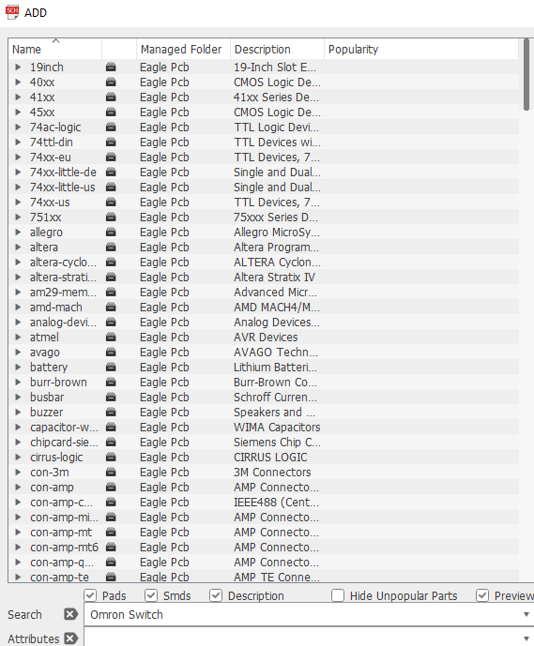

Figure 6: Search Omron Switch

Step 10: Click 10-XX Omron Switch as shown in Figure 7.

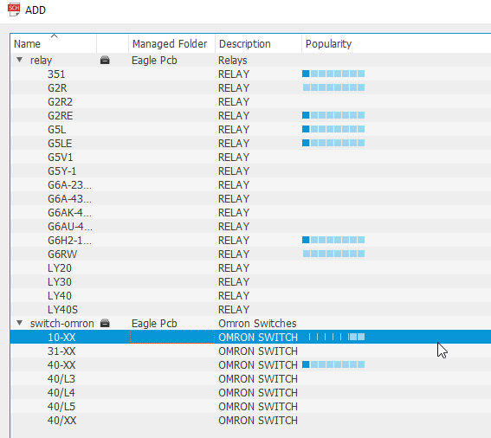

Figure 7: 10-XX Omron Switch

Step 11: Place switch in the middle and hit Esc key as shown in Figure 8.

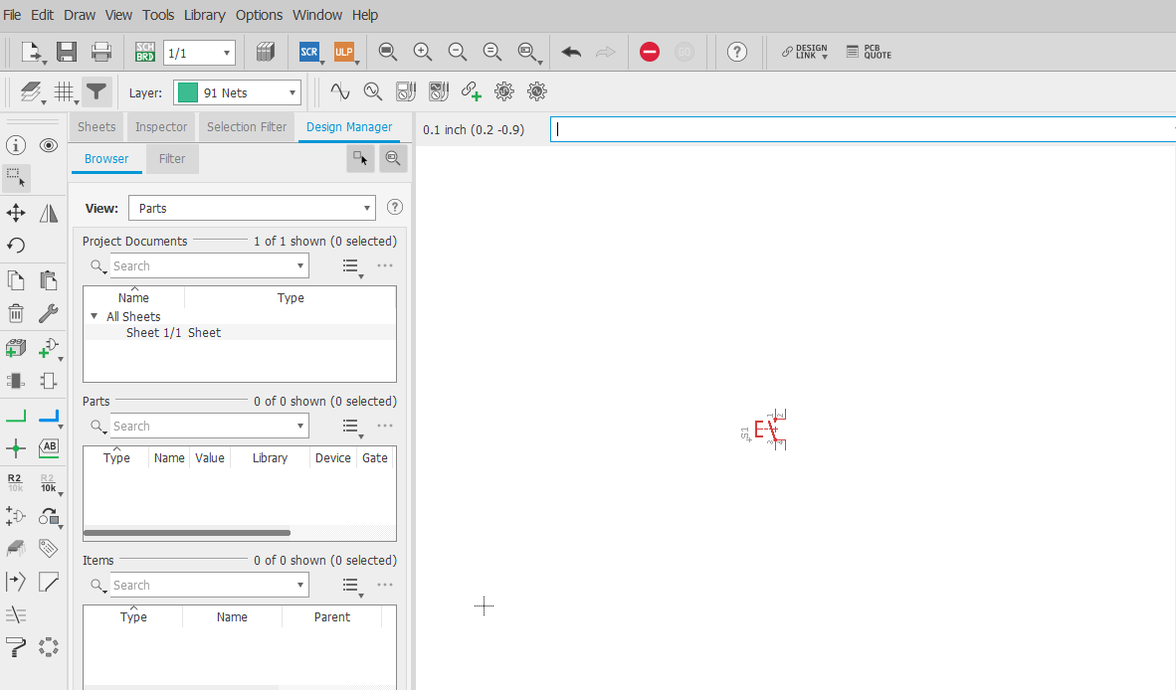

Figure 8: Place Omron Switch 10-XX

Step 12: Click the Rotate as shown in Figure 9.

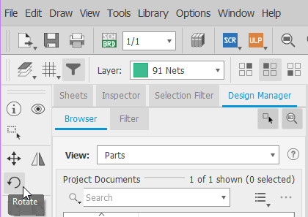

Figure 9: Click Rotate

Step 13: Click switch 3 times. Hit Esc Key.

Step 14: Move the switch up to the top of the schematic. Click Move as shown in Figure 10.

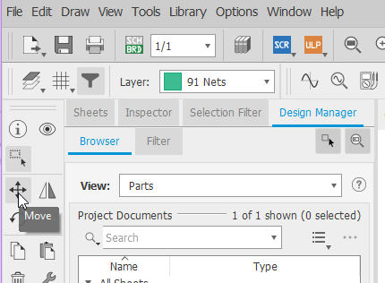

Figure 10: Click Move

Step 15: Left click and hold button to move the switch. You want to click in the center of the switch or on the +. Position switch at top of the schematic and release the left mouse button to place part.

Step 16: Search for LED5mm. Click the Add Part again as shown in Figure 5. Type LED5mm in the Search field and Click OK. Now Click LED5MM as shown in Figure 11.

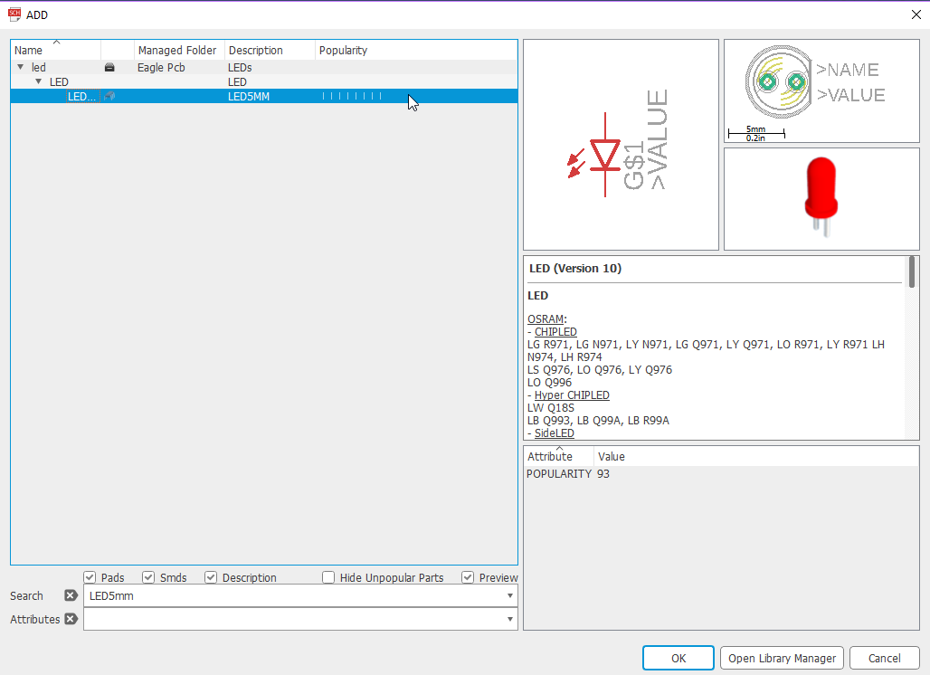

Figure 11: Click the RED LED

Step 17: Click twice in the schematic to place 2 LEDs quickly. Try to place them in the approximation desired locations as shown in Figure 12.

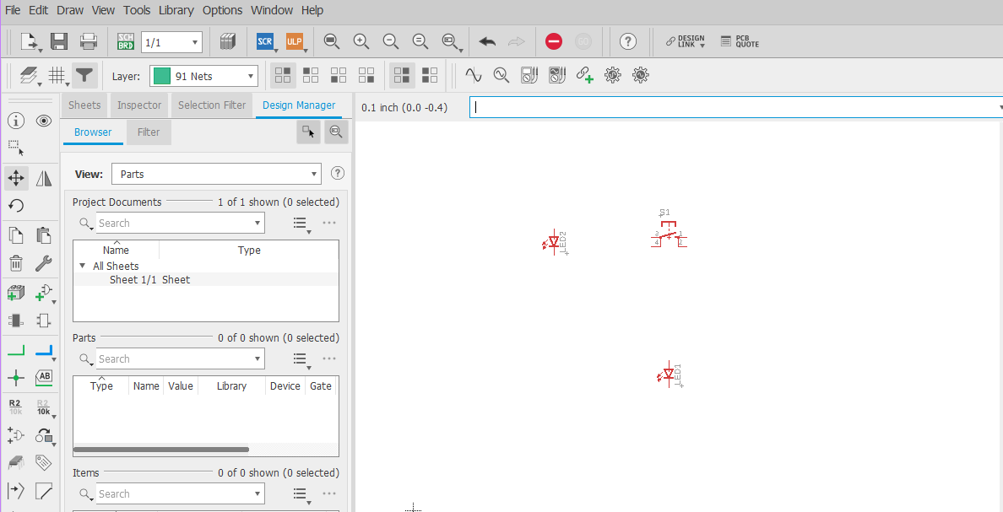

Figure 12: Place 2 LEDs.

Step 18: Rotate the LEDs where cathodes are pointing the left. Click the Rotate icon as shown previously in Figure 9. Click each LED 3 times to rotate them to desired position as shown in Figure 13.

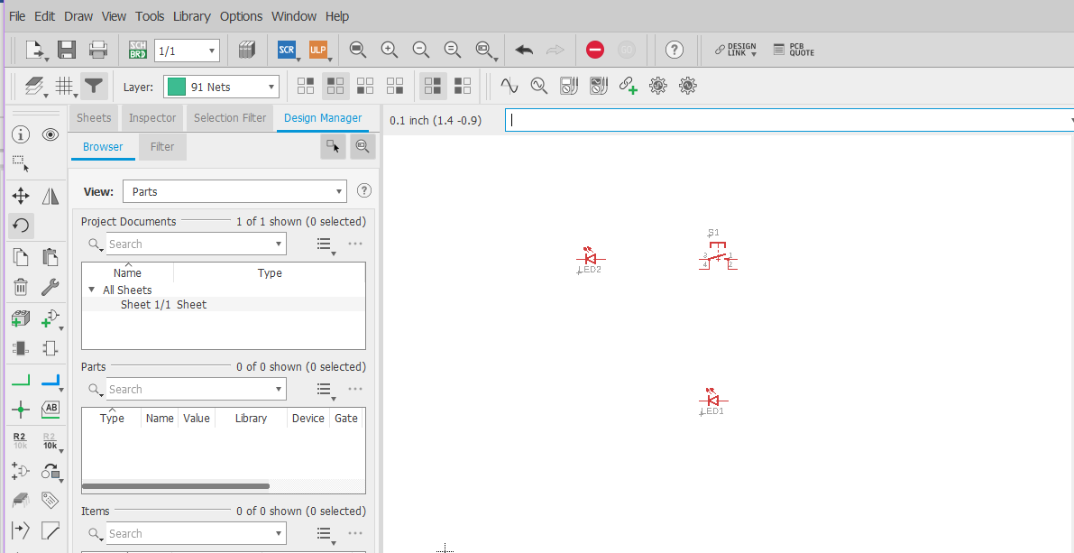

Figure 13: Rotate LEDs

Step 19: Add the resistor. Click Add Part again and search for resistor. Click R-US_ as shown in Figure 14.

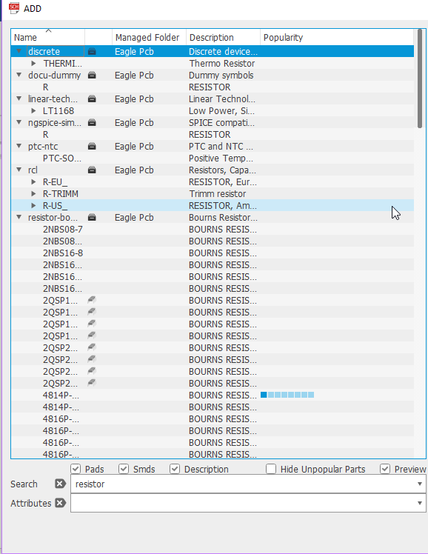

Figure 14: Search resistor R-US_

Step 20: Now you are ready to pick the right Description for resistor in the popup window shown in Figure 15. Try to place it to right of LED1. Click 0207/12 and place in schematic to the right of LED1. Click to place, then Hit Esc key.

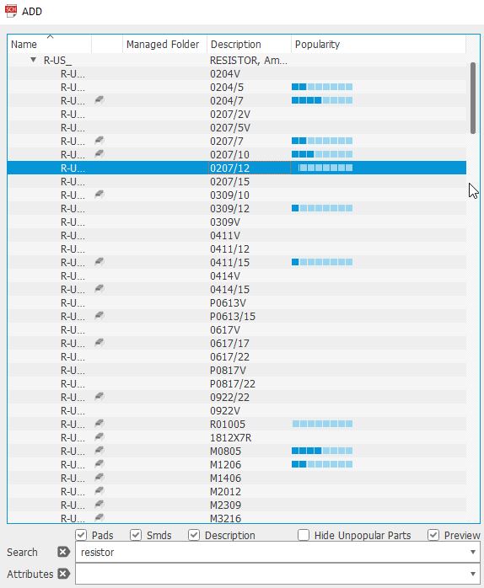

Figure 15: Resistor R-US_ Description 0207/12

Step 21: Type potentiometer in the Search field. Select Description 3223G as shown in Figure 16. Place part to the bottom left position of schematic. Click to place, then Hit Esc key.

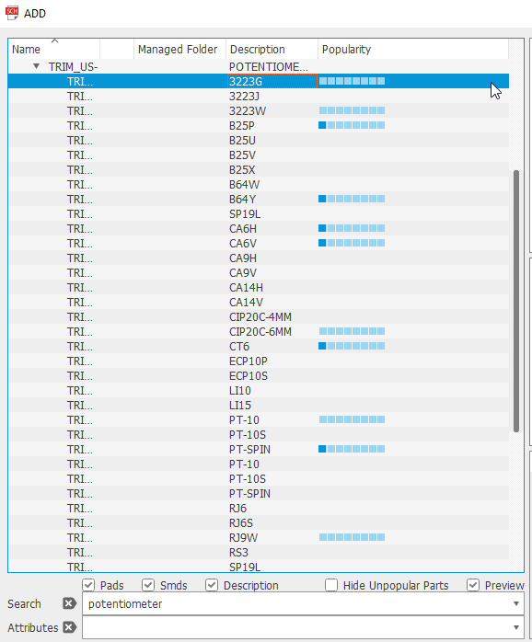

Figure 16: Potentiometer Description 3223G

Step 22: Type connector in Search field. Scroll down until you get to con-amp-quick. Pick type M02 as shown in Figure 17. Place part in bottom right corner of schematic. Hit Esc key, then hit Cancel to close Search window for parts.

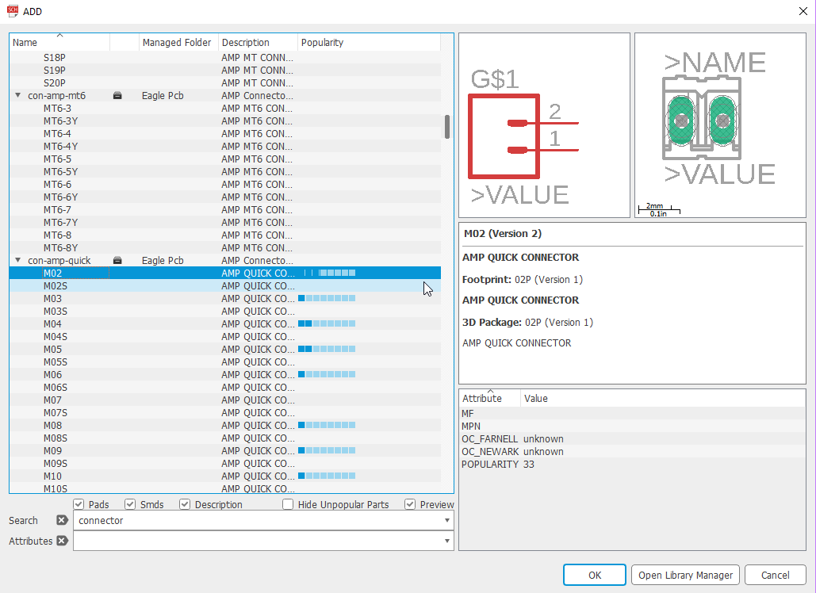

Figure 17: Connector con-amp-quick – Type M02

Step 23: Observe Figure 18 placement of parts. Compare to Figure 4 Schematic. We need to rotate SL1 connector.

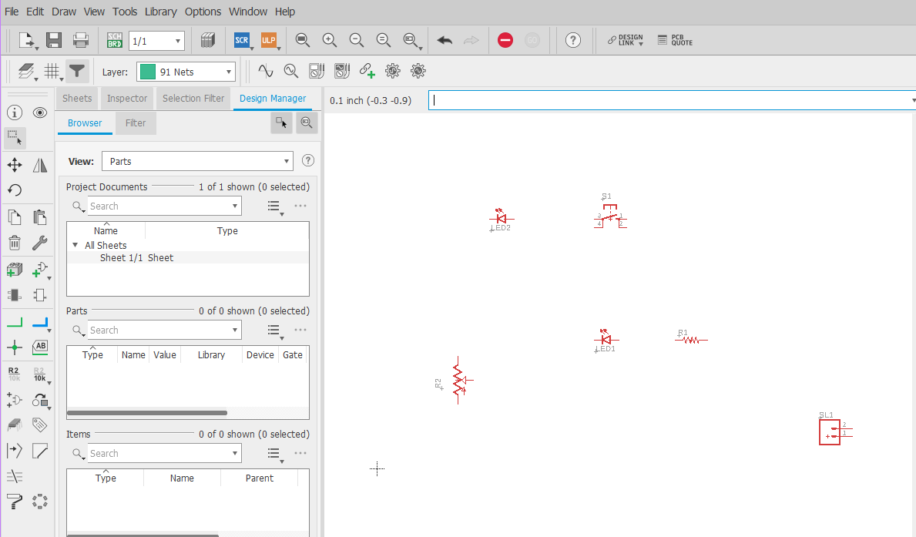

Figure 18: Placement of Parts

Step 24: Rotate the SL1 connector. Click the Rotate icon on the left. Now click over the + sign on the SL1 connector 2 times. Hit the Esc key.

Step 25: Turn on the Grid, so you can align things easier as shown in Figure 19. Click View, then Grid. Now Click Display On, and OK.

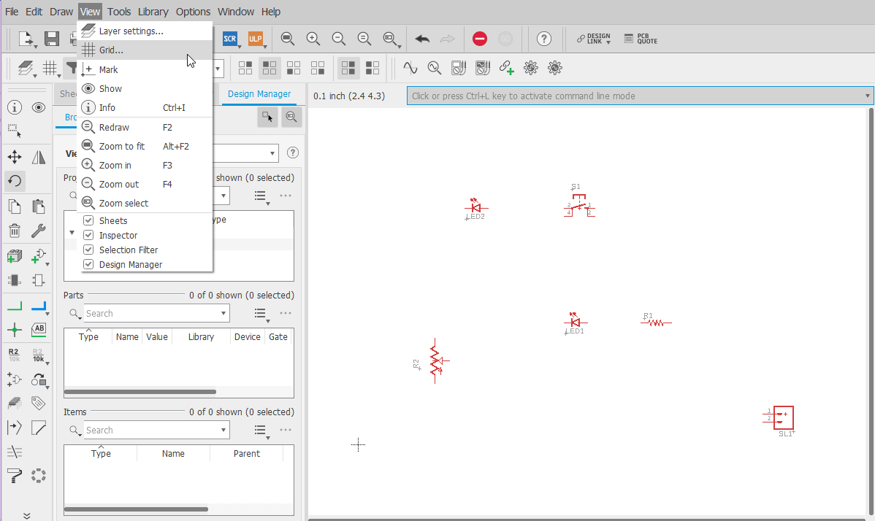

Figure 19: Apply Grid View

Step 26: Click the Move key and position things as close as possible to Figure 4. See Figure 20.

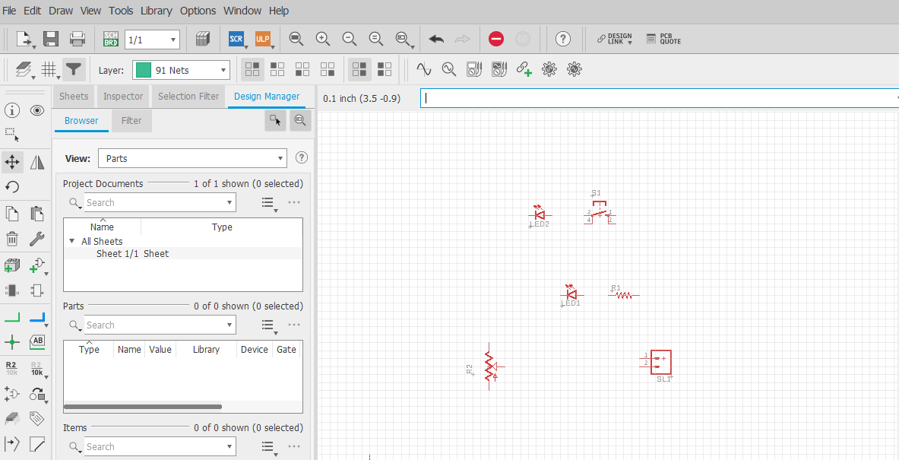

Figure 20: Grid View and Move

Step 27: Start wiring. Click the Net as shown in Figure 21. This is sort like wiring in Tinkercad. Wire it up!

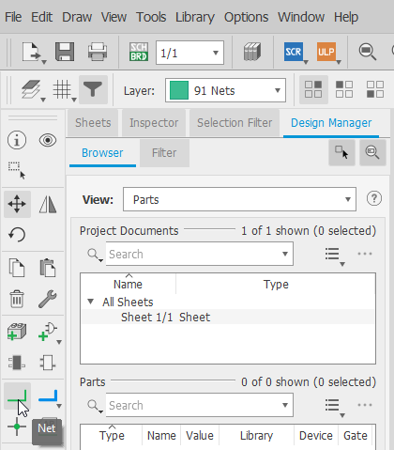

Figure 21: Start Wiring with Net

Step 28: Finished Product. This looks like Figure 4 minus the Grid View.

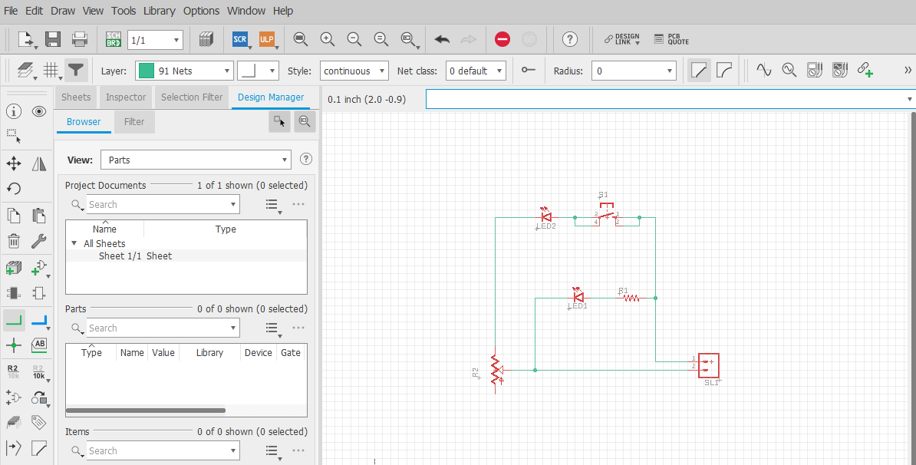

Figure 22: Grid View for Exercise Schematic

Step 29: Save your file as Exercise

* File, Save As, Type Exercise, Save
* File extension .sch automatically appends.